
Mini Project Report
on
Health and Wellness Blog Site
For the course
Web Programming Laboratory
Submitted by
Aaryan Sharma
Roll No: 16010123012
Aditey Kshirsagar
Roll No: 16010123017
Aditya Baheti
Roll No: 16010123023

Guide
Deepa Jain

Department of Computer Engineering
K. J. Somaiya School of Engineering
Somaiya Vidyavihar University

DECLARATION
I declare that the written Mini Project report submission represents the work done based on my and / or others’ ideas with adequately cited and referenced the original source. I also declare that I have adhered to all principles of academic honesty and integrity as per norms of the Somaiya Vidyavihar University. I have not misinterpreted, fabricated, or falsified any idea/data/fact/source/original work/matter in my submission.
I understand that any violation of the above will be cause for disciplinary action by the university and may evoke the penal action from the sources which have not been properly cited or from whom proper permission is not sought.

Roll NO: 16010123012  Student Name: Aaryan Sharma  Signature | Roll NO: 16010123017  Student Name: Aditey Kshirsagar  Signature
Roll NO: 16010123023
Student Name: Aditya Baheti
Signature

Date: 20 / 04 / 2025
Place: Mumbai-77
Report Includes: This as on separate pages
- Application Web Development: Title
- Literature Review about Application (With references)
- Need Statement:
- Objectives:
- Flow of pages: login, catalogue, menus, feedback, etc
- Figma design, Database Schema
- conclusion
- future scope
Health and Wellness Blogs
A Platform to Promote Healthy Living and Well-being
https://github.com/Aaryan-Sharma-5/Health-and-Wellness-Blog

Literature Review
The evolution of health and wellness platforms has significantly enhanced awareness surrounding mental, physical, and emotional well-being. As digital access becomes more widespread, individuals increasingly turn to online resources for information on nutrition, exercise, mindfulness, and general health practices. Prominent platforms such as WebMD, Healthline, and Verywell Fit have set benchmarks by offering expert-curated articles, while community-driven websites allow users to share personal experiences and wellness journeys.
Online Health Information-Seeking Behavior
Research indicates a growing trend in online health information-seeking behavior. For instance, a study by Kumar et al. (2020) found that a significant proportion of individuals in urban settlements actively search for health-related content online, emphasizing the demand for credible and accessible wellness information. Similarly, Ghweeba et al. (2017) observed that personal characteristics influence the likelihood of seeking health information online, highlighting the importance of tailoring content to diverse audiences.
Impact of Author Credentials on Trust
The credibility of online health information is closely tied to the perceived expertise of the content's author. Hu and Sundar (2010) demonstrated that users are more likely to trust and engage with health information authored by individuals with medical credentials. Their study revealed that author credentials significantly influence perceptions of expertise, benevolence, and integrity, thereby affecting the overall credibility of the information presented.
Color Psychology in Healthcare Web Design
Visual design elements, particularly color schemes, play a crucial role in user engagement and trust in health platforms. According to Scacca (2024), blue and green are the most commonly used colors in healthcare branding, associated with tranquility, stability, and trust. These colors can create a calming environment, which is essential in healthcare settings where users may be experiencing anxiety or stress.
User Engagement and Community Features
While specific studies on the impact of community features on user engagement in health blogs are limited, general web design principles suggest that interactive elements such as comment sections, discussion forums, and user testimonials can enhance user engagement and foster a sense of community. Incorporating these features may lead to increased user satisfaction and retention.
In summary, existing literature consistently emphasizes that successful health and wellness blogs rely on a combination of trustworthy content, intuitive design, engaging community features, and personalization strategies. These factors together shape user trust, interaction, and long-term platform success.

References
Kumar, R., Singh, P., & Yadav, R. (2020). Determinants of online health information-seeking behavior: A cross-sectional survey among residents of an urban settlement in Delhi. Journal of Education and Health Promotion, 9, Article 242
Hu, Y., & Sundar, S. S. (2010). Effects of online health sources on credibility and behavioral intentions. Communication Research, 37(1), 105–132
Zhang, Y., He, D., & Sang, Y. (2021). Online health information seeking behavior: A systematic review. Journal of Medical Internet Research, 23(12), e26635
Lee, H. Y., Lee, J., & Kim, N. (2021). Role of health literacy in health-related information-seeking behavior online: Cross-sectional study. Journal of Medical Internet Research, 23(1), e14068
Ghweeba, M., Lindenmeyer, A., Shishi, S., Abbas, M., Waheed, A., & Amer, S. (2017). What predicts online health information-seeking behavior among Egyptian adults? A cross-sectional study. Journal of Medical Internet Research, 19(6), e216
Finney Rutten, L. J., Blake, K. D., Greenberg-Worisek, A. J., Allen, S. V., Moser, R. P., & Hesse, B. W. (2019). Online health information seeking among US adults: Measuring progress toward a Healthy People 2020 objective. Public Health Reports, 134(6), 617–625
Scacca, S. (2024, December 5). Using color psychology for healthcare web design

Need Statement
There is an increasing demand for centralized, user-friendly health and wellness platforms that not only educate users but also encourage active engagement. Many existing platforms fall short in areas such as personalization, inclusivity of diverse user voices, or practical, adaptable health guidance based on individual needs. This blog aims to bridge the gap between professional advice and real-life experiences by offering a dynamic space where users can learn, share, and grow together in their wellness journeys.
Market Analysis
The global digital health market is experiencing rapid growth, valued at $196.3 billion in 2024, with projections to reach $383.5 billion by 2030 (Digital Health Trends Report, 2025). Within this evolving ecosystem, health and wellness blogs play a critical role by connecting users to reliable health insights, actionable lifestyle advice, and peer-driven communities. The rising preference for remote health resources and self-guided wellness tools positions such platforms at the forefront of user-centric healthcare innovation.
Solution Opportunity
H&W seeks to fill this gap by offering an integrated platform that combines:
- Evidence-based content
- Personalized wellness journeys
- Interactive community features
The platform’s accessible and intuitive design promotes long-term user engagement, making it not just a blog but a digital wellness companion. By delivering trustworthy, personalized guidance alongside peer support and professional resources, H&W empowers users to make sustainable, informed decisions for their overall well-being.

Objectives
General Goals
- Provide credible, easy-to-understand health and wellness content.
- Enable users to engage via reactions, comments, and content sharing and Empower editors to publish and manage blog posts efficiently.
- Deliver a simple and intuitive UI/UX using modern web technologies.
- Foster community growth through interactive features and discussions.

Primary Objectives
1. Deliver Evidence-Based Health Content
- Ensure that content is authored by certified health professionals.
- Implement rigorous fact-checking protocols and citation standards.
2. Create Personalized User Experiences
- Develop a content recommendation engine based on user behaviour and profiles and allow users to customize dashboards.
- Provide content with adaptive difficulty levels based on user knowledge and preferences.
3. Build Engaged Wellness Communities
- Launch topic-specific community forums with professional moderation.
- Integrate gamification features to reward active participation.

Technical Objectives
1. Create a Robust Content Management System
- Enable tag-based and hierarchical content categorization with multi-faceted filters.
- Implement version-controlled editorial workflows for secure and trackable updates.
- Design modular templates optimized for articles, videos, infographics, etc.
3. Integrate Third-Party Health Systems
- Build secure API integrations for wearable devices (e.g., Fitbit, Apple Health).
- Enable connections to electronic health record (EHR) systems, where feasible.
- Partner with external health services for seamless referrals and collaborations.
Flow of Pages
1. Login/Signup – User authentication system.
2. Homepage – Featured, trending, and latest blog posts.
3. Catalogue – Browse content by categories: Fitness, Nutrition, Mental Health, etc.
4. Blog Details – Full article view with reaction buttons and comments.
5. Create Post – For Editors/Admins to publish content.
6. Dashboard – Panel to manage posts.
7. Contact Us – Users can share suggestions, report bugs, or request help.

Figma Design
https://www.figma.com/design/u0cXRu5oDJRaLdOU39zQQR/Health-and-Wellness-Blog?node-id=0-1&p=f&t=k3vgIsW1HU0hsjnC-0

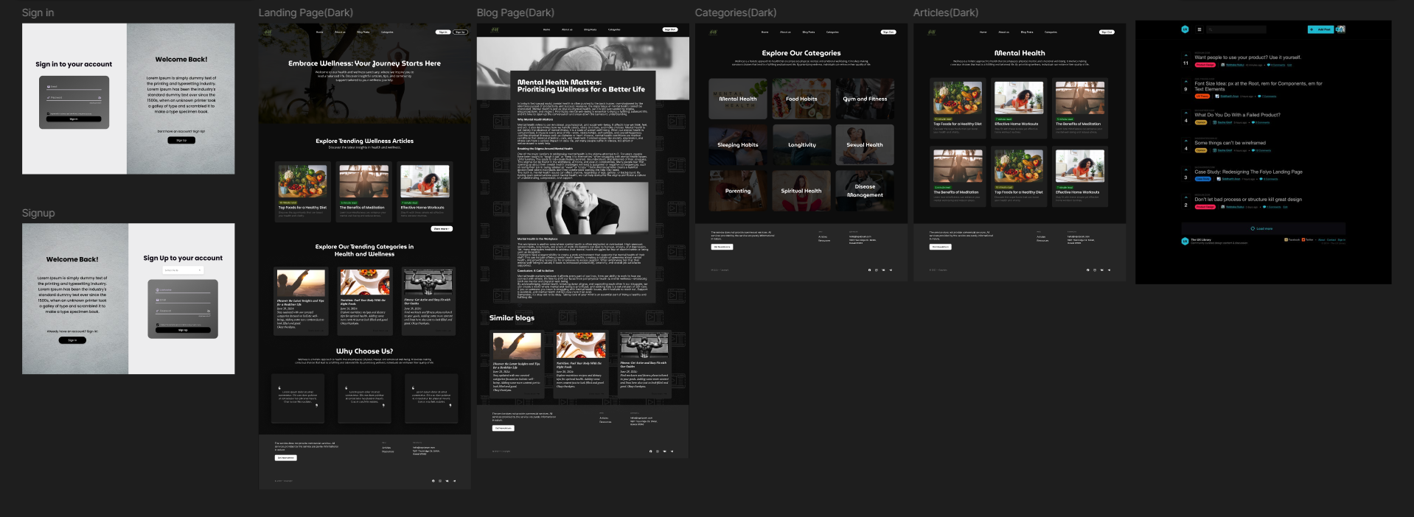
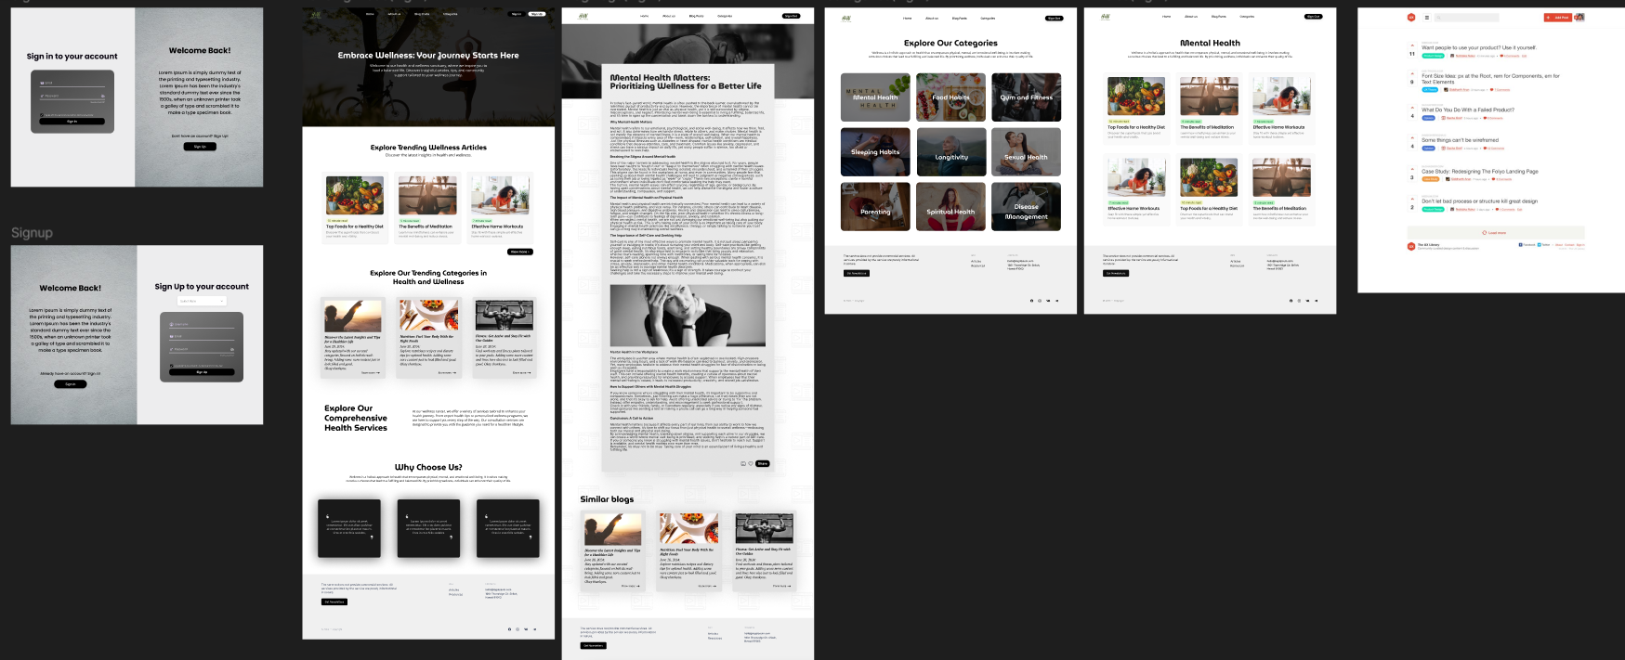

Database Schema
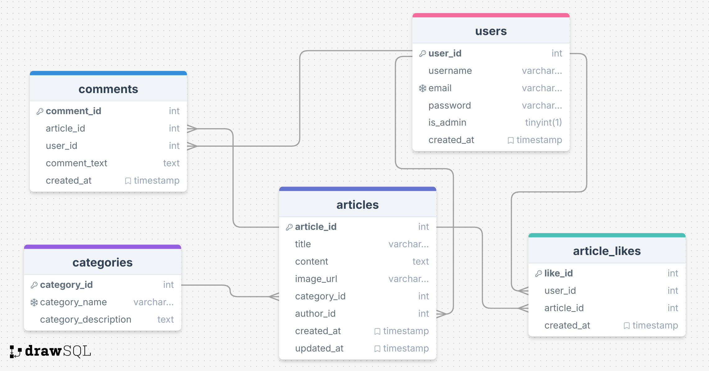

Conclusion
The H&W Health and Wellness Blog platform serves as a robust, user-centered resource for accessing, engaging with, and contributing to health-related content. By combining evidence-based information, personalized user experiences, and strong community features, the platform advances digital health information delivery, community building, and personal wellness tracking. Its intuitive design, secure backend infrastructure, and emphasis on fostering a sense of community ensure both credibility and usability, addressing critical gaps in the current health and wellness landscape while promoting well-being.

Future Scope
The H&W platform establishes a robust foundation for digital health engagement; however, as it matures, significant opportunities exist to elevate its reach, functionality, and impact. This section outlines strategic pathways for future development that will expand the platform’s value proposition and enhance user outcomes.
1. Content and Knowledge Expansion
- Multimedia Content Library- Produce original video series featuring subject matter experts.
- Specialized Knowledge Centers - Develop life-stage wellness portals (prenatal, adolescence, aging).
2. Advanced Technology Integration
- Artificial Intelligence Applications
  - Utilize machine learning to recognize user health patterns.
  - Offer predictive analytics for preventative health insights.
- Biometric Data Integration
  - Interpret continuous glucose monitoring and sleep quality data.
  - Provide insights from heart rate variability and stress analysis.
3. Community and Social Engagement
- Enhanced Support Systems
  - Introduce peer coaching and accountability groups.
  - Create gamified challenges to drive engagement.
  - Establish a marketplace of certified wellness professionals.
- Knowledge Exchange Frameworks
  - Enable user-generated content pathways with expert moderation.
  - Build a wisdom-sharing repository from community experiences.
  - Implement verification mechanisms for peer-contributed content.
  - Facilitate collaborative forums for solving health-specific challenges.
- Evidence-Based Research
  - Conduct clinical studies to validate platform methodologies.
  - Apply behavioural economics to refine user engagement strategies.
  - Compare digital interventions with traditional methods.
  - Publish research findings to contribute to the digital health field.

By strategically pursuing these future enhancements while staying true to its core principles—evidence-based content, user-centered design, and supportive community development—the H&W platform is well-positioned to evolve into a globally trusted wellness companion. Its continued innovation will empower individuals, strengthen communities, and positively influence health outcomes on a broader scale.

